**Progressive Education Society’s**

**MODERN COLLEGE OF ENGINEERING**

Pune 411005.



**A PROJECT REPORT ON “HOSTEL MANAGEMENT SYSTEM ”**

**By**

27003 - Yash Bhoge 27010 - Vedant Deokar 27018 - Pritesh Gadiya 27076 - Darshan Taskar

Under the guidance of

**Mrs. SUPRIYA JAGTAP**

In partial fulfillment of S.E (Information Technology) Savitribai Phule Pune University

PUNE 2020-21

**Progressive Education Society's Modern College Of Engineering, Pune-05. Department of Information Technology**

**2021-22**

Certificate



This is to certify that, project entitled “**HOSTEL MANAGEMENT SYSTEM**”, Submitted by **PURVI PORWAL,RASHI TAWRI,RITIKA WAZA,TEJASWINI KENJALRA** is record of bonofide work carried out by them, under the guidance of **Mrs.Swapna Bhavsar**, in fulfillment of the requirement for the award of the

S.E. of Bachelor of Engineering in **Information Technology,** Savitribai Phule Pune University.

**Ms. S.M. Jagtap Dr. Mrs. S. D. Deshpande**

**GUIDE H.O.D (IT)**

Date: Place: Pune

# Acknowledgement

We take this occasion to thank God, almighty for blessing us with his grace and taking our endeavour to a successful culmination. We extend our sincere and heart felt thanks to our

esteemed guide, **Prof.Mrs Supriya Jagtap** for providing us with the right guidance and advice at the crucial junctures and for showing us the right way. We extend our sincere thanks to our respected head of the division **Prof.Mrs.S.D.Deshpande** for allowing us to use the facilities available. We would like to thank the other faculty members also, at this occasion. Last but not

the least, we would like to thank friends for the support and encouragement they have given us during the course of our work.

**YASH BHOGE VEDANT DEOKAR PRITESH GADIYA DARSHAN TASKAR**

# Abstract

As the name specifies “HOSTEL MANAGEMENT SYSTEM” is a software developed

for managing various activities in the hostel. For the past few years the number of educational institutions are increasing rapidly. Thereby the number of hostels are also increasing for the accommodation of the students studying in this institution. And hence there is a lot of strain on the person who are running the hostel and software’s are not usually used in this context. This particular project deals with the problems on managing a hostel and avoids the problems which occur when carried manually. Identification of the drawbacks of the existing system leads to the designing of computerized system that will be compatible to the existing system with the system Which is more user friendly and more GUI oriented. We can improve the efficiency of the system, thus overcome the drawbacks of the existing system.

* Less human error
* Strength and strain of manual labour can be reduced
* High security
* Data redundancy can be avoided to some extent
* Data consistency
* Easy to handle
* Easy data updating
* Easy record keeping
* Backup data can be easily generated

# INDEX

|  |  |  |
| --- | --- | --- |
| **Sr.no.** | **Contents** | **Page**  **no.** |
| 1 | Project Title | **6** |
| 2 | Introduction of your project | **6** |
| 3 | Scope& Limitations | **7** |
| 4 | Requirement Analysis | **8** |
| 5 | Feasibility study | **10** |
| 6 | Software Requirement Specification   1. Software requirements 2. Hardware requirements | **12** |
| 7 | ER Diagram | **13** |
| 8 | ER to Table Conversion | **14** |
| 9 | Schema Diagram | **15** |
| 10 | Schema Definitions | **16** |
| 11 | Project Plan | **22** |
| 12 | Graphical User Interfaces/Screen Shots | **29** |
| 13 | Project Code | **30** |
| 14 | Future Enhancement | **31** |
| 15 | Conclusion |  |
| 16 | References |  |

**PROJECT TITLE: HOSTEL MANAGEMENT SYSTEM**

# Introduction of your project

All the hostels at present are managed manually by the hostel office. The Registration form verification to the different data processing are done manually. Thus there are a lot of repetitions which can be easily avoided. And hence there is a lot of strain on the person who are running the hostel and software’s are not usually used in this context. This particular project deals with the problems on managing a hostel and avoids the problems which occur when carried manually Identification of the drawbacks of the existing system leads to the designing of computerized system that will be compatible to the existing system with the system which is more user friendly and more GUI oriented. We can improve the efficiency of the system, thus overcome the drawbacks of the existing system.

# Problem Statement:

To design the Hostel Management System for automating the activities of hostel.

The aim of the Hostel Management System is to carry out the activities of hostel in an efficient way. It will take the operations of hostel to higher level by providing faster access to data and allowing addition, upgradation, modification, and deletion of data in a very systematic and reliable manner.

# Scope& Limitations:

**SCOPE:**

* This project enables user to store all the data in one place.
* Long term storage is possible.
* Data Security.
* Data consistency.
* Accuracy in calculations.
* Data redundancy.
* Easy user Interface.

# LIMITATIONS:

* To pay the fees we do not have online mode currently.
* The database is for one gender i.e. girls only.
* The hostel cannot handle other issues like mess acitvity, because the existing doesn’t have one.
* Only admin can access the data in the database file.

# Requirement Analysis

In [systems engineering](https://en.wikipedia.org/wiki/Systems_engineering) and [software engineering](https://en.wikipedia.org/wiki/Software_engineering), **requirements analysis** focuses on the tasks that determine the needs or conditions to meet the new or altered product or project, taking account of the possibly conflicting [requirements](https://en.wikipedia.org/wiki/Requirement) of the various [stakeholders](https://en.wikipedia.org/wiki/Stakeholder_(corporate)), analyzing, documenting, validating and managing software or system requirements.

Requirements analysis is critical to the success or failure of a systems or [software project](https://en.wikipedia.org/wiki/Software_project_management). The requirements should be documented, actionable, measurable, testable, traceable, related to identified business needs or opportunities, and defined to a level of detail sufficient for system design.

The modules used in our database are:

* Resident: The person living in the hostel is named as resident. They would have to fill out their whole information in the database when asked by the webpage thus making it easier for someone to keep track of the records.
* Room allocation: Each room will be allocated to resident to live in with sharing it with the other members if the hostel.
* Local Guardian: Every resident entering the hostel would be asked to fill in their local guardian information just to keep a record if needed in emergency.
* Complaints: This table will be based on the complaints a resident wants to file in for the ongoing hostel facilities or any problem they might be facing in the hostel so it could help out the wardens or administrator to help them out.
* Fees details : The structure of the fees will be shown here as well as if a person has paid her fees or not will also be shown ere just so that the admin can keep a check on them.
* Organization: This table will tell us about the organization they work inn or study in just to know more about the living resident and it would help the admin or warden to know them better and easy to communicate.

# FEASIBILITY STUDY

Feasibility Study is basically the test of the proposed system in the light of its workability, meeting user’s requirements, effective use of resources and of course, the cost effectiveness. As the name implies, feasibility study is an analysis of the viability of an idea. It ensures that a project is legally and technically feasible and economically justifiable. Moreover this study can be used in various ways with focus on the proposed business. It tells us whether a project is worth doable or not? Feasibility study is a must because: A feasibility study evaluates the project's potential for success; therefore, perceived objectivity is an important factor in the credibility of the study for potential investors and lending institutions The main goal of feasibility study is not to solve the problem but to achieve the scope. In the process of feasibility study, the cost and benefits are estimated with greater accuracy. It has three types:

* Operational Feasibility
* Technical Feasibility
* Economic Feasibility

**Economic Feasibility:** Economic analysis is the most frequently used method for evaluating the effectiveness of a new system. More commonly known as cost/benefit analysis. PHP using IDE and MySQL database easily available Script Server Side (like XAMAP/ WAMAP) in internet. This procedure is to determine the benefits and savings that are expected from a candidate system and compare them with costs. If benefits outweigh costs, then the decision is made to design and implement the system. Otherwise, further justification or alterations in proposed system will have to be made if it is to have a chance of being approved. This is an ongoing effort that improves in accuracy at each phase of the system life cycle. Economic feasibility talks about the benefits that which we get from this project. Here with the introduction of this online process we are not only reducing the time take for the registration of the entrants. We even reduce the burden on the administrator. As this project is not only reducing the time but also the work burden of the user we say that this product is economically feasible.

**Technical Feasibility:** The technical feasibility in the proposed system deals with the technology used in the system. It deals with the hardware and software used in the system whether they are of latest technology or not. It happens that after a system is prepared a new technology arises and the user wants the system based on that technology. This system use windows platform, JAVA as front end technology and MySQL server as backend technology. Thus HOSTEL MANAGEMENT SYSTEM is technically feasible. Technical feasibility centers on the existing computer system (hardware, software, etc.,) and to what extent it can support the proposed addition. If the budget is a serious constraint, then the project is judged not feasible. Technical feasibility speaks about the existing hardware and the software that we are using and the

deviations that we have to make from the existing one, as we are developing the application using java there is no change in the hardware that we are using. So we a say that this application is technically feasible as there is no change in the configuration more over it is cost effective.

**Operational Feasibility:** The project has been developed in such a way that it becomes very easy even for a person with little computer knowledge to operate it. People are inherently resistant to change, and computers have been known to facilitate change. It is understandable that the introduction of a candidate system requires special effort to educate, sell, and train the staff on new ways of conducting business. As this project is a user friendly version there is not much training required for the people to use. This product is not only making the task of the administrator easy but it is reducing the time that is taken otherwise. So we say that this product is operationally feasible.

# SOFTWARE REQUIREMENT SPECIFICATION

**Hardware Configuration**

The most common set of requirements defined by any operating system or software application is

the physical computer resources, also known as hardware. Processor : Pentium IV Processor And Above

RAM : 512 MB RAM

Hard Disk : 40GB HDD

Monitor : 1024 * 768 Resolution Color Monitor

# Software Configuration

Software Requirements deal with defining software resource requirements and pre-requisites that need to be installed on a computer to provide optimal functioning of an application.

Operating System : Windows XP/ Windows7/ Windows8/ Windows10 Front End : JAVA NETBEANS

Back End : MySQL

# ER DIAGARAM

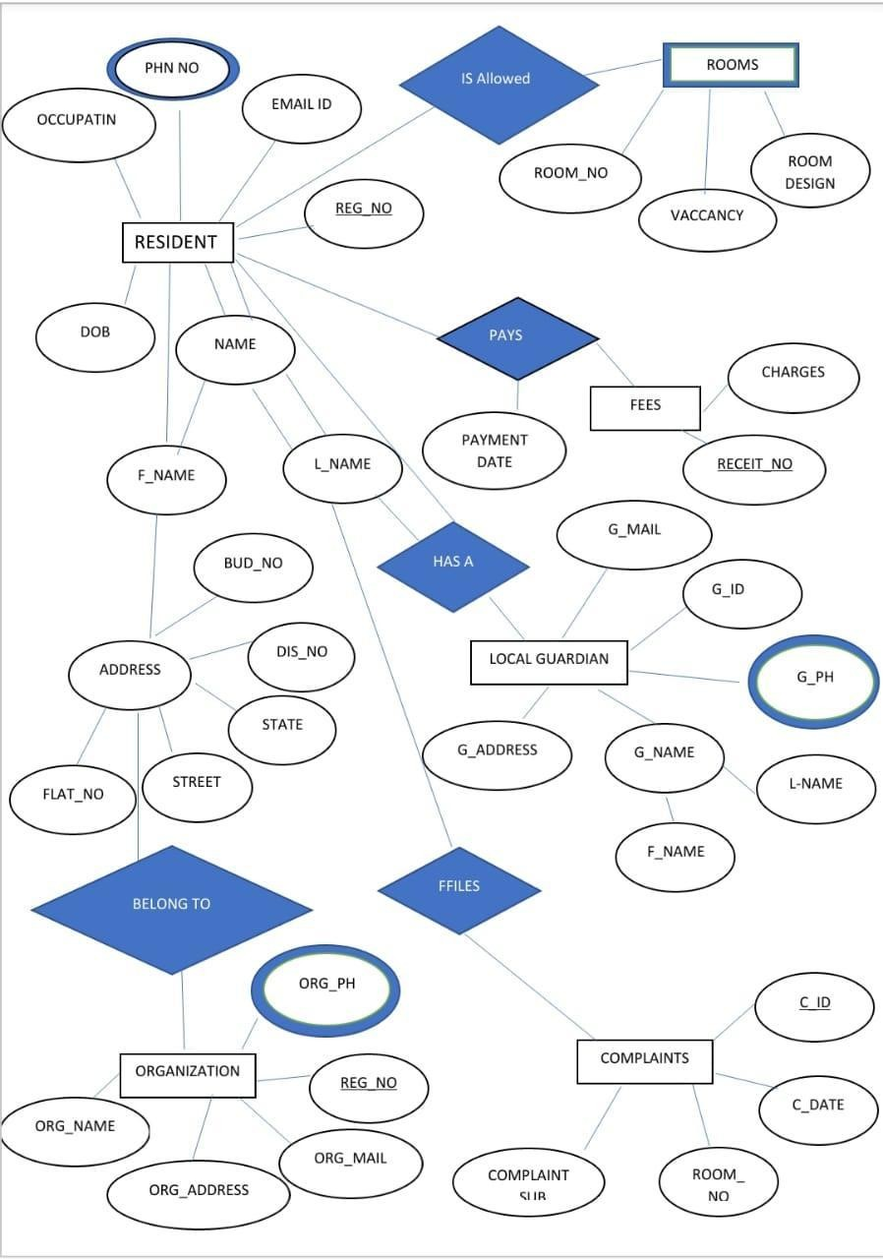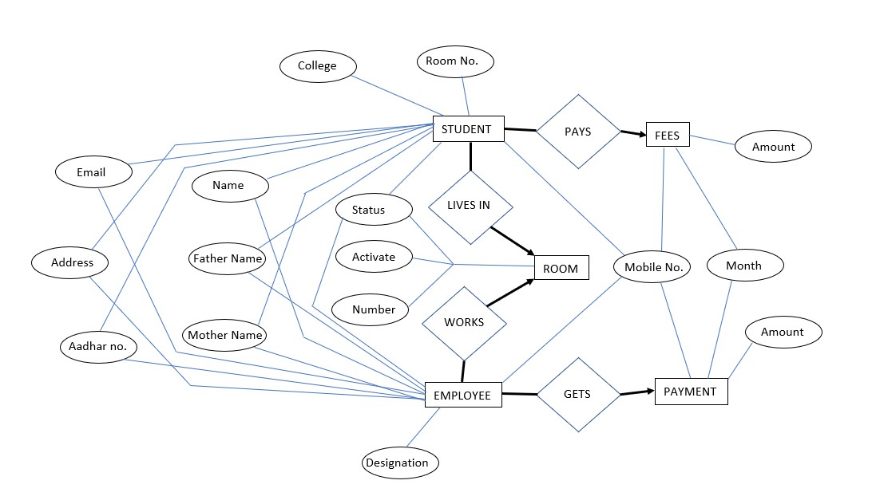

mobile

# ER TO TABLE CONVERSION

|  |  |  |  |
| --- | --- | --- | --- |
| moble | **TABLE** | **COLUMNS** | **PRIMARY KEY** |
| 1. | Room | number , activate ,roomStatus | number |
| 2. | Student | mobileNo ,name ,father , mother , email , address college , aadhaar, roomNo ,status | mobileNo |
| 3. | Fees | mobileNo, month, amount | mobileNo |
| 4. | Employee | mobileNo , name, father, mother, email, address, aadhaar, designation , status | mobileNo |
| 5. | Payment | mobileNo, month, amount |  |

**SCHEMA DIAGRAM**

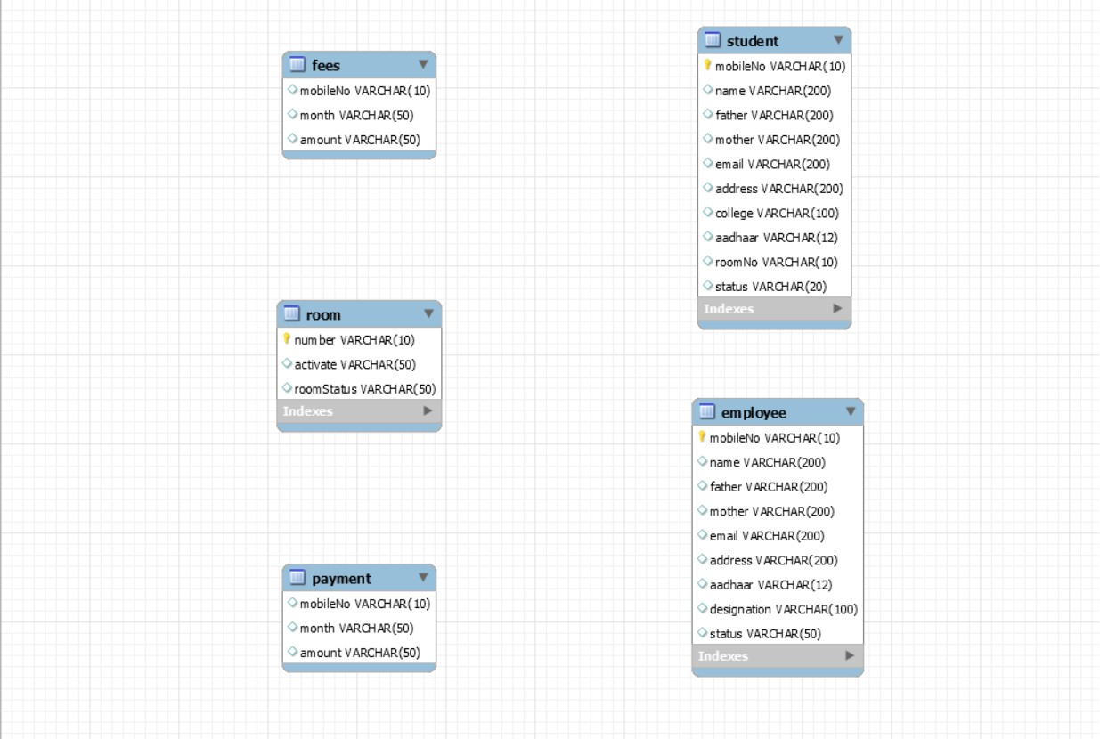

# SCHEMA DEFINITIONS

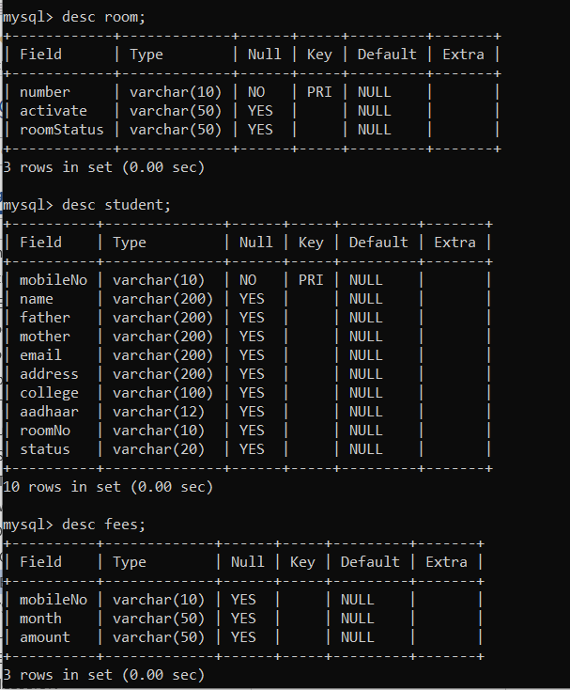

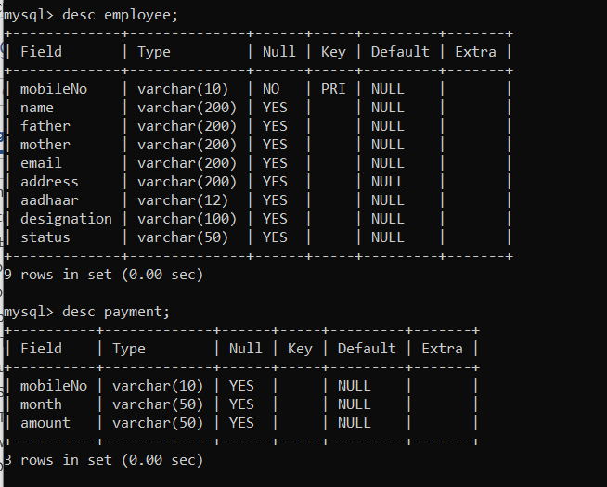

# GUI/SCREEN SHOTS

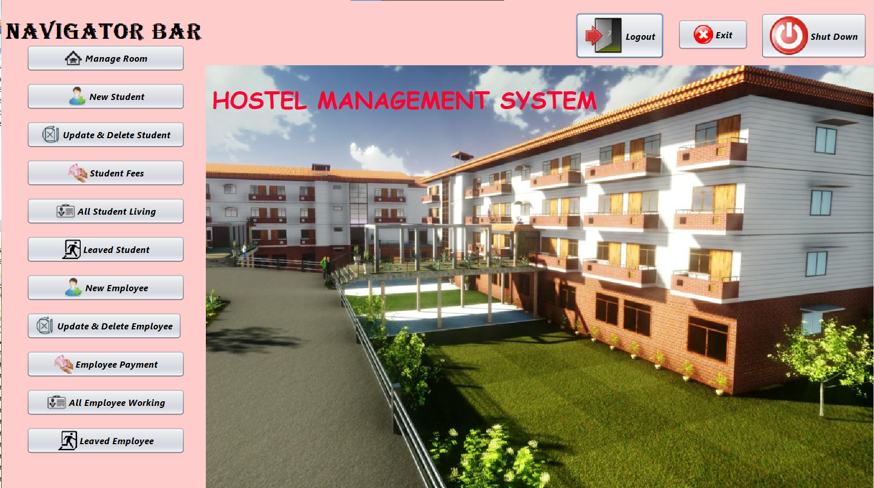

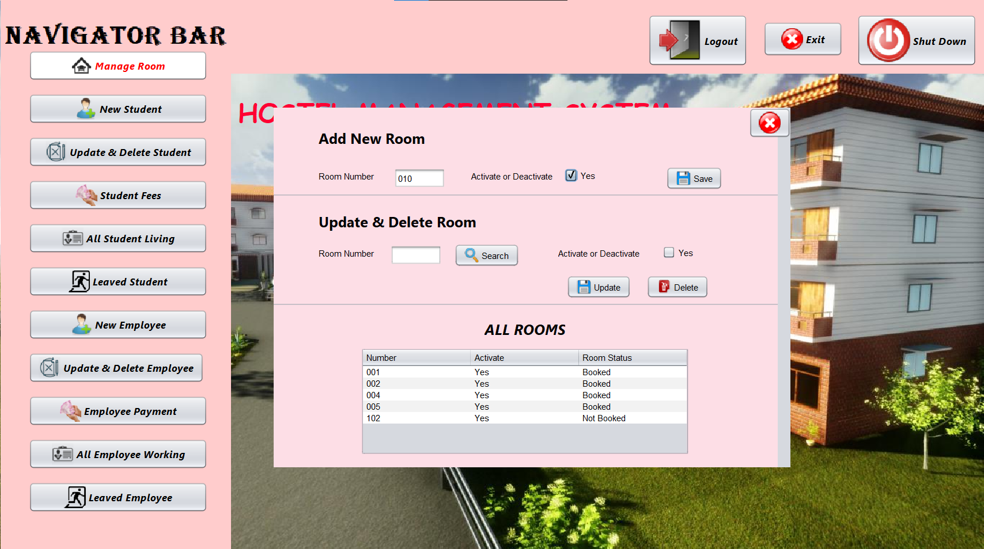

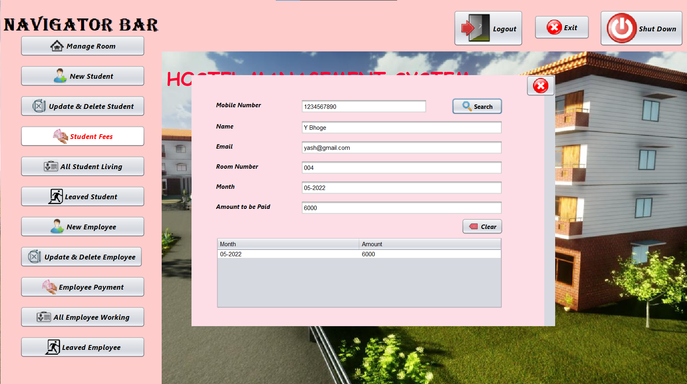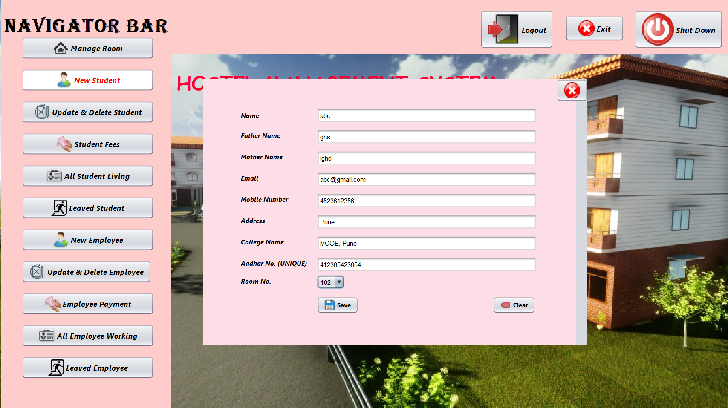

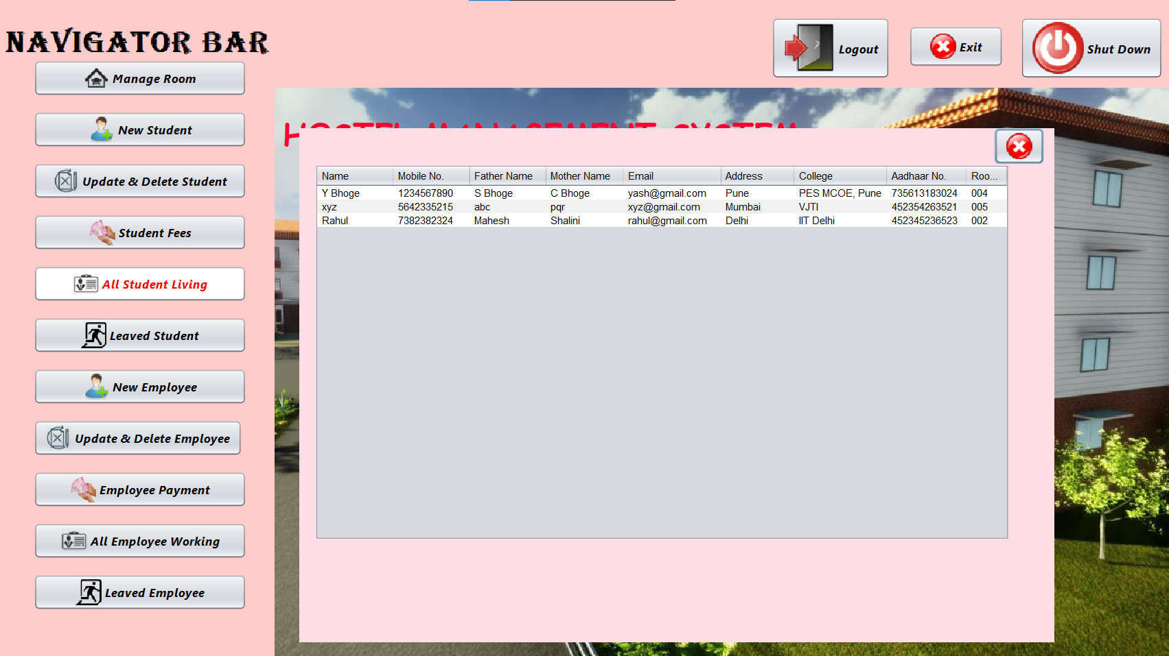

**IMPLEMENTATION /PROJECT CODE**

**HOME PAGE CODE :-**

package hostel.management.system;

import java.awt.Color;

import javax.swing.*;

import java.sql.PreparedStatement;

import java.sql.SQLException;

/**

*

* @author khush

*/

public class home extends javax.swing.JFrame {

/**

* Creates new form home

*/

public home() {

initComponents();

}

/**

* This method is called from within the constructor to initialize the form.

* WARNING: Do NOT modify this code. The content of this method is always

* regenerated by the Form Editor.

*/

@SuppressWarnings("unchecked")

// <editor-fold defaultstate="collapsed" desc="Generated Code">

private void initComponents() {

jButton1 = new javax.swing.JButton();

jButton2 = new javax.swing.JButton();

jButton3 = new javax.swing.JButton();

jButton4 = new javax.swing.JButton();

jButton5 = new javax.swing.JButton();

jButton6 = new javax.swing.JButton();

jButton7 = new javax.swing.JButton();

jButton8 = new javax.swing.JButton();

jButton9 = new javax.swing.JButton();

jButton10 = new javax.swing.JButton();

jButton11 = new javax.swing.JButton();

jButton12 = new javax.swing.JButton();

jButton13 = new javax.swing.JButton();

jButton14 = new javax.swing.JButton();

jLabel1 = new javax.swing.JLabel();

jLabel3 = new javax.swing.JLabel();

jLabel2 = new javax.swing.JLabel();

setDefaultCloseOperation(javax.swing.WindowConstants.EXIT_ON_CLOSE);

setLocation(new java.awt.Point(100, 0));

setUndecorated(true);

addWindowFocusListener(new java.awt.event.WindowFocusListener() {

public void windowGainedFocus(java.awt.event.WindowEvent evt) {

formWindowGainedFocus(evt);

}

public void windowLostFocus(java.awt.event.WindowEvent evt) {

}

});

getContentPane().setLayout(new org.netbeans.lib.awtextra.AbsoluteLayout());

jButton1.setFont(new java.awt.Font("Segoe UI", 3, 14)); // NOI18N

jButton1.setIcon(new javax.swing.ImageIcon(getClass().getResource("/images/room.png"))); // NOI18N

jButton1.setText("Manage Room");

jButton1.addMouseMotionListener(new java.awt.event.MouseMotionAdapter() {

public void mouseMoved(java.awt.event.MouseEvent evt) {

jButton1MouseMoved(evt);

}

});

jButton1.addActionListener(new java.awt.event.ActionListener() {

public void actionPerformed(java.awt.event.ActionEvent evt) {

jButton1ActionPerformed(evt);

}

});

getContentPane().add(jButton1, new org.netbeans.lib.awtextra.AbsoluteConstraints(40, 70, 248, -1));

jButton2.setFont(new java.awt.Font("Segoe UI", 3, 14)); // NOI18N

jButton2.setIcon(new javax.swing.ImageIcon(getClass().getResource("/images/new student.png"))); // NOI18N

jButton2.setText("New Student");

jButton2.addActionListener(new java.awt.event.ActionListener() {

public void actionPerformed(java.awt.event.ActionEvent evt) {

jButton2ActionPerformed(evt);

}

});

getContentPane().add(jButton2, new org.netbeans.lib.awtextra.AbsoluteConstraints(40, 130, 248, -1));

jButton3.setFont(new java.awt.Font("Segoe UI", 3, 14)); // NOI18N

jButton3.setIcon(new javax.swing.ImageIcon(getClass().getResource("/images/Update & Delete Student.png"))); // NOI18N

jButton3.setText("Update & Delete Student");

jButton3.addActionListener(new java.awt.event.ActionListener() {

public void actionPerformed(java.awt.event.ActionEvent evt) {

jButton3ActionPerformed(evt);

}

});

getContentPane().add(jButton3, new org.netbeans.lib.awtextra.AbsoluteConstraints(40, 190, 248, -1));

jButton4.setFont(new java.awt.Font("Segoe UI", 3, 14)); // NOI18N

jButton4.setIcon(new javax.swing.ImageIcon(getClass().getResource("/images/Fees.png"))); // NOI18N

jButton4.setText("Student Fees");

jButton4.addActionListener(new java.awt.event.ActionListener() {

public void actionPerformed(java.awt.event.ActionEvent evt) {

jButton4ActionPerformed(evt);

}

});

getContentPane().add(jButton4, new org.netbeans.lib.awtextra.AbsoluteConstraints(40, 250, 248, -1));

jButton5.setFont(new java.awt.Font("Segoe UI", 3, 14)); // NOI18N

jButton5.setIcon(new javax.swing.ImageIcon(getClass().getResource("/images/all student living.png"))); // NOI18N

jButton5.setText("All Student Living");

jButton5.addActionListener(new java.awt.event.ActionListener() {

public void actionPerformed(java.awt.event.ActionEvent evt) {

jButton5ActionPerformed(evt);

}

});

getContentPane().add(jButton5, new org.netbeans.lib.awtextra.AbsoluteConstraints(40, 310, 248, -1));

jButton6.setFont(new java.awt.Font("Segoe UI", 3, 14)); // NOI18N

jButton6.setIcon(new javax.swing.ImageIcon(getClass().getResource("/images/Leaved students.png"))); // NOI18N

jButton6.setText("Leaved Student");

jButton6.addActionListener(new java.awt.event.ActionListener() {

public void actionPerformed(java.awt.event.ActionEvent evt) {

jButton6ActionPerformed(evt);

}

});

getContentPane().add(jButton6, new org.netbeans.lib.awtextra.AbsoluteConstraints(40, 370, 248, -1));

jButton7.setFont(new java.awt.Font("Segoe UI", 3, 14)); // NOI18N

jButton7.setIcon(new javax.swing.ImageIcon(getClass().getResource("/images/new student.png"))); // NOI18N

jButton7.setText("New Employee");

jButton7.addActionListener(new java.awt.event.ActionListener() {

public void actionPerformed(java.awt.event.ActionEvent evt) {

jButton7ActionPerformed(evt);

}

});

getContentPane().add(jButton7, new org.netbeans.lib.awtextra.AbsoluteConstraints(40, 430, 248, -1));

jButton8.setFont(new java.awt.Font("Segoe UI", 3, 14)); // NOI18N

jButton8.setIcon(new javax.swing.ImageIcon(getClass().getResource("/images/Update & Delete Student.png"))); // NOI18N

jButton8.setText("Update & Delete Employee");

jButton8.addActionListener(new java.awt.event.ActionListener() {

public void actionPerformed(java.awt.event.ActionEvent evt) {

jButton8ActionPerformed(evt);

}

});

getContentPane().add(jButton8, new org.netbeans.lib.awtextra.AbsoluteConstraints(40, 490, -1, -1));

jButton9.setFont(new java.awt.Font("Segoe UI", 3, 14)); // NOI18N

jButton9.setIcon(new javax.swing.ImageIcon(getClass().getResource("/images/Fees.png"))); // NOI18N

jButton9.setText("Employee Payment");

jButton9.addActionListener(new java.awt.event.ActionListener() {

public void actionPerformed(java.awt.event.ActionEvent evt) {

jButton9ActionPerformed(evt);

}

});

getContentPane().add(jButton9, new org.netbeans.lib.awtextra.AbsoluteConstraints(40, 550, 248, -1));

jButton10.setFont(new java.awt.Font("Segoe UI", 3, 14)); // NOI18N

jButton10.setIcon(new javax.swing.ImageIcon(getClass().getResource("/images/all student living.png"))); // NOI18N

jButton10.setText("All Employee Working");

jButton10.addActionListener(new java.awt.event.ActionListener() {

public void actionPerformed(java.awt.event.ActionEvent evt) {

jButton10ActionPerformed(evt);

}

});

getContentPane().add(jButton10, new org.netbeans.lib.awtextra.AbsoluteConstraints(40, 610, 248, -1));

jButton11.setFont(new java.awt.Font("Segoe UI", 3, 14)); // NOI18N

jButton11.setIcon(new javax.swing.ImageIcon(getClass().getResource("/images/Leaved students.png"))); // NOI18N

jButton11.setText("Leaved Employee");

jButton11.addActionListener(new java.awt.event.ActionListener() {

public void actionPerformed(java.awt.event.ActionEvent evt) {

jButton11ActionPerformed(evt);

}

});

getContentPane().add(jButton11, new org.netbeans.lib.awtextra.AbsoluteConstraints(40, 670, 248, -1));

jButton12.setFont(new java.awt.Font("Segoe UI", 3, 14)); // NOI18N

jButton12.setIcon(new javax.swing.ImageIcon(getClass().getResource("/images/logout.png"))); // NOI18N

jButton12.setText("Logout");

jButton12.addActionListener(new java.awt.event.ActionListener() {

public void actionPerformed(java.awt.event.ActionEvent evt) {

jButton12ActionPerformed(evt);

}

});

getContentPane().add(jButton12, new org.netbeans.lib.awtextra.AbsoluteConstraints(900, 20, -1, -1));

jButton13.setFont(new java.awt.Font("Segoe UI", 3, 14)); // NOI18N

jButton13.setIcon(new javax.swing.ImageIcon(getClass().getResource("/images/Close all jframe.png"))); // NOI18N

jButton13.setText("Exit");

jButton13.setMaximumSize(new java.awt.Dimension(168, 66));

jButton13.setMinimumSize(new java.awt.Dimension(168, 66));

jButton13.setPreferredSize(new java.awt.Dimension(168, 66));

jButton13.addActionListener(new java.awt.event.ActionListener() {

public void actionPerformed(java.awt.event.ActionEvent evt) {

jButton13ActionPerformed(evt);

}

});

getContentPane().add(jButton13, new org.netbeans.lib.awtextra.AbsoluteConstraints(1060, 30, 110, 48));

jButton14.setFont(new java.awt.Font("Segoe UI", 3, 14)); // NOI18N

jButton14.setIcon(new javax.swing.ImageIcon(getClass().getResource("/images/shut Down.png"))); // NOI18N

jButton14.setText("Shut Down");

jButton14.addActionListener(new java.awt.event.ActionListener() {

public void actionPerformed(java.awt.event.ActionEvent evt) {

jButton14ActionPerformed(evt);

}

});

getContentPane().add(jButton14, new org.netbeans.lib.awtextra.AbsoluteConstraints(1190, 20, -1, -1));

getContentPane().add(jLabel1, new org.netbeans.lib.awtextra.AbsoluteConstraints(460, 30, -1, -1));

jLabel3.setFont(new java.awt.Font("Comic Sans MS", 1, 36)); // NOI18N

jLabel3.setForeground(new java.awt.Color(255, 0, 51));

jLabel3.setText("HOSTEL MANAGEMENT SYSTEM");

getContentPane().add(jLabel3, new org.netbeans.lib.awtextra.AbsoluteConstraints(330, 130, 610, -1));

jLabel2.setIcon(new javax.swing.ImageIcon(getClass().getResource("/images/home background.PNG"))); // NOI18N

getContentPane().add(jLabel2, new org.netbeans.lib.awtextra.AbsoluteConstraints(0, 0, -1, -1));

pack();

}// </editor-fold>

private void jButton1ActionPerformed(java.awt.event.ActionEvent evt) {

// TODO add your handling code here:

jButton1.setForeground(Color.red);

jButton1.setBackground(new Color(255,255,255));

new ManageRoom().setVisible(true);

}

private void jButton14ActionPerformed(java.awt.event.ActionEvent evt) {

// TODO add your handling code here:

int a=JOptionPane.showConfirmDialog(null,"Do you really want to logout?","select",JOptionPane.YES_NO_OPTION);

if(a==0) {

Runtime runtime=Runtime.getRuntime();

try{

Process proc = runtime.exec("shutdown -s -t 0");

}

catch(Exception e){

JOptionPane.showMessageDialog(null, e);

}

}

}

private void jButton13ActionPerformed(java.awt.event.ActionEvent evt) {

// TODO add your handling code here:

int a=JOptionPane.showConfirmDialog(null,"Do you really want to exit?","select",JOptionPane.YES_NO_OPTION);

if(a==0) {

System.exit(0);

}

}

private void formWindowGainedFocus(java.awt.event.WindowEvent evt) {

// TODO add your handling code here:

jButton1.setForeground(new JButton().getForeground());

jButton1.setBackground(new JButton().getBackground());

jButton2.setForeground(new JButton().getForeground());

jButton2.setBackground(new JButton().getBackground());

jButton3.setForeground(new JButton().getForeground());

jButton3.setBackground(new JButton().getBackground());

jButton4.setForeground(new JButton().getForeground());

jButton4.setBackground(new JButton().getBackground());

jButton5.setForeground(new JButton().getForeground());

jButton5.setBackground(new JButton().getBackground());

jButton6.setForeground(new JButton().getForeground());

jButton6.setBackground(new JButton().getBackground());

jButton7.setForeground(new JButton().getForeground());

jButton7.setBackground(new JButton().getBackground());

jButton8.setForeground(new JButton().getForeground());

jButton8.setBackground(new JButton().getBackground());

jButton9.setForeground(new JButton().getForeground());

jButton9.setBackground(new JButton().getBackground());

jButton10.setForeground(new JButton().getForeground());

jButton10.setBackground(new JButton().getBackground());

jButton11.setForeground(new JButton().getForeground());

jButton11.setBackground(new JButton().getBackground());

}

private void jButton12ActionPerformed(java.awt.event.ActionEvent evt) {

// TODO add your handling code here:

int a=JOptionPane.showConfirmDialog(null,"Do you really want to logout?","select",JOptionPane.YES_NO_OPTION);

if(a==0) {

setVisible(false);

new login().setVisible(true);

}

}

private void jButton2ActionPerformed(java.awt.event.ActionEvent evt) {

// TODO add your handling code here:

jButton2.setForeground(Color.red);

jButton2.setBackground(new Color(255,255,255));

new NewStudent().setVisible(true);

}

private void jButton3ActionPerformed(java.awt.event.ActionEvent evt) {

// TODO add your handling code here:

jButton3.setForeground(Color.red);

jButton3.setBackground(new Color(255,255,255));

new UpdateDeleteStudent().setVisible(true);

}

private void jButton1MouseMoved(java.awt.event.MouseEvent evt) {

// TODO add your handling code here:

}

private void jButton4ActionPerformed(java.awt.event.ActionEvent evt) {

// TODO add your handling code here:

jButton4.setForeground(Color.red);

jButton4.setBackground(new Color(255,255,255));

new StudentFees().setVisible(true);

}

private void jButton5ActionPerformed(java.awt.event.ActionEvent evt) {

// TODO add your handling code here:

jButton5.setForeground(Color.red);

jButton5.setBackground(new Color(255,255,255));

new AllStudentsLiving().setVisible(true);

}

private void jButton6ActionPerformed(java.awt.event.ActionEvent evt) {

// TODO add your handling code here:

jButton6.setForeground(Color.red);

jButton6.setBackground(new Color(255,255,255));

}

private void jButton7ActionPerformed(java.awt.event.ActionEvent evt) {

// TODO add your handling code here:

jButton7.setForeground(Color.red);

jButton7.setBackground(new Color(255,255,255));

new NewEmployee().setVisible(true);

}

private void jButton8ActionPerformed(java.awt.event.ActionEvent evt) {

// TODO add your handling code here:

jButton8.setForeground(Color.red);

jButton8.setBackground(new Color(255,255,255));

}

private void jButton9ActionPerformed(java.awt.event.ActionEvent evt) {

// TODO add your handling code here:

jButton9.setForeground(Color.red);

jButton9.setBackground(new Color(255,255,255));

}

private void jButton10ActionPerformed(java.awt.event.ActionEvent evt) {

// TODO add your handling code here:

jButton10.setForeground(Color.red);

jButton10.setBackground(new Color(255,255,255));

new AllEmployeeWorking().setVisible(true);

}

private void jButton11ActionPerformed(java.awt.event.ActionEvent evt) {

// TODO add your handling code here:

jButton11.setForeground(Color.red);

jButton11.setBackground(new Color(255,255,255));

}

/**

* @param args the command line arguments

*/

public static void main(String args[]) {

/* Set the Nimbus look and feel */

//<editor-fold defaultstate="collapsed" desc=" Look and feel setting code (optional) ">

/* If Nimbus (introduced in Java SE 6) is not available, stay with the default look and feel.

* For details see http://download.oracle.com/javase/tutorial/uiswing/lookandfeel/plaf.html

*/

try {

for (javax.swing.UIManager.LookAndFeelInfo info : javax.swing.UIManager.getInstalledLookAndFeels()) {

if ("Nimbus".equals(info.getName())) {

javax.swing.UIManager.setLookAndFeel(info.getClassName());

break;

}

}

} catch (ClassNotFoundException ex) {

java.util.logging.Logger.getLogger(home.class.getName()).log(java.util.logging.Level.SEVERE, null, ex);

} catch (InstantiationException ex) {

java.util.logging.Logger.getLogger(home.class.getName()).log(java.util.logging.Level.SEVERE, null, ex);

} catch (IllegalAccessException ex) {

java.util.logging.Logger.getLogger(home.class.getName()).log(java.util.logging.Level.SEVERE, null, ex);

} catch (javax.swing.UnsupportedLookAndFeelException ex) {

java.util.logging.Logger.getLogger(home.class.getName()).log(java.util.logging.Level.SEVERE, null, ex);

}

//</editor-fold>

/* Create and display the form */

java.awt.EventQueue.invokeLater(new Runnable() {

public void run() {

new home().setVisible(true);

}

});

}

// Variables declaration - do not modify

private javax.swing.JButton jButton1;

private javax.swing.JButton jButton10;

private javax.swing.JButton jButton11;

private javax.swing.JButton jButton12;

private javax.swing.JButton jButton13;

private javax.swing.JButton jButton14;

private javax.swing.JButton jButton2;

private javax.swing.JButton jButton3;

private javax.swing.JButton jButton4;

private javax.swing.JButton jButton5;

private javax.swing.JButton jButton6;

private javax.swing.JButton jButton7;

private javax.swing.JButton jButton8;

private javax.swing.JButton jButton9;

private javax.swing.JLabel jLabel1;

private javax.swing.JLabel jLabel2;

private javax.swing.JLabel jLabel3;

// End of variables declaration

}

# FUTURE ENHANCEMENT

* To pay the fees we intend to start online mode.
* The database is for one gender i.e. girls only thus we can make it for coed.
* The hostel cannot handle other issues like mess activity, because the existing doesn’t have one, thus we can add one or more tables regarding the issues and complaints we get.
* The expanded functionality of today’s software requires an appropriate approach towards software development. This hostel management software is designed for people who want to manage various activities in the hostel. For the past few years the number of educational institutions are increasing rapidly. Thereby the number of hostels are also increasing for the accommodation of the students studying in this institution. And hence there is a lot of strain on the person who are running the hostel and software’s are not usually used in this context. This particular project deals with the problems on managing a hostel and avoids the problems which occur when carried manually. Identification of the drawbacks of the existing system leads to the designing of computerized system that will be compatible to the existing system with the system which is more user friendly and more GUI oriented

# CONCLUSION

To conclude the description about the project : The project, developed using JAVA and MySQL is based on the requirement specification of the user and the analysis of the existing system, with flexibility for future enhancement.

# REFERNCES

1. [www.w3schools.com](http://www.w3schools.com/)
2. in.php.net
3. en.wikipedia.org/wiki/PHP

4 . [www.hotscripts.com/category/php/](http://www.hotscripts.com/category/php/)

1. [www.apache.org/](http://www.apache.org/)
2. [www.mysql.com/click.php?e=35050](http://www.mysql.com/click.php?e=35050)